# **Helminths – FRCPath Part 2 Short Notes**

## **1. Trematodes (Flukes)**

**Schistosoma spp.**

* **Epidemiology/Geography:**
  + *S. haematobium* → Africa, Middle East.
  + *S. mansoni* → Africa, Middle East, South America, Caribbean.
  + *S. japonicum* → China, Philippines, SE Asia.
* **Transmission:** Skin penetration by cercariae from **freshwater snails.**
* **Clinical:**
  + *S. haematobium* → urinary schistosomiasis, ↑ bladder carcinoma risk.
  + *S. mansoni* → intestinal + hepatosplenic disease.
  + *S. japonicum* → more severe hepatosplenic disease.
* **Diagnostics:** Eggs in stool/urine (terminal vs lateral spines), serology, antigen detection (CCA).
* **Treatment:** Praziquantel (40 mg/kg).
* **Public health:** WHO mass drug administration (MDA).

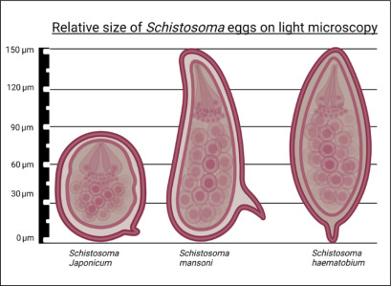

### **Clonorchis sinensis / Opisthorchis spp.**

* **Geography:** China, Korea, Vietnam, Thailand, Laos, Cambodia.
* **Transmission:** Ingestion of metacercariae in **raw freshwater fish.**
* **Clinical:** Biliary obstruction, cholangitis, **cholangiocarcinoma risk**.
* **Diagnostics:** **Small** operculated eggs in stool.
* **Treatment:** Praziquantel.

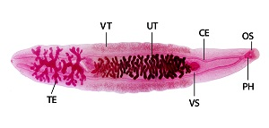

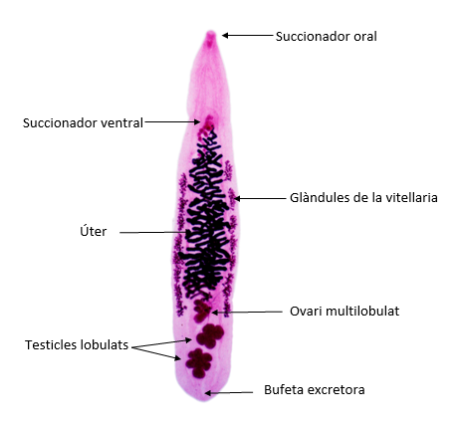

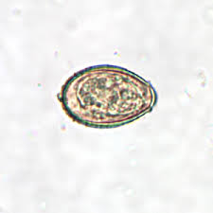

Small operculated egg

### **Fasciola hepatica**

* **Epidemiology:** Sheep-raising areas worldwide; **watercress ingestion.**
* **Transmission:** Ingestion of metacercariae on aquatic plants.
* **Clinical:** Acute (fever, RUQ pain, eosinophilia); chronic (biliary obstruction).
* **Diagnostics:** **Large** operculated eggs in stool, serology.
* **Treatment:** **Triclabendazole** (not praziquantel).

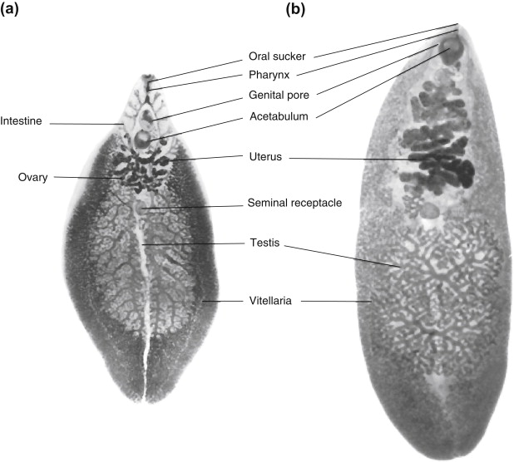

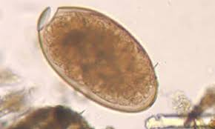

### **Paragonimus westermani**

* **Epidemiology:** Asia; raw/undercooked **freshwater crab/crayfish.**
* **Clinical:** Pulmonary infection (cough, haemoptysis, TB mimic); ectopic CNS disease.
* **Diagnostics:** Operculated eggs in sputum/stool.
* **Treatment:** Praziquantel.
* 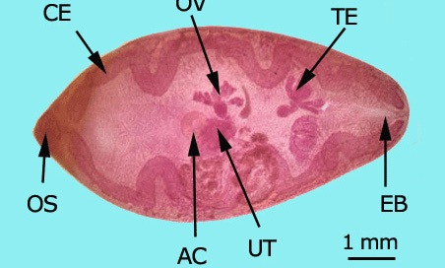

## **2. Cestodes (Tapeworms)**

### **Taenia saginata / Taenia solium**

* **Epidemiology:** Worldwide, esp. where **beef/pork undercooked.**
* **Transmission:** Ingestion of cysticerci in meat.
* **Clinical:** Intestinal taeniasis; **T. solium → cysticercosis (CNS seizures)**.
* **Diagnostics:** Eggs (radial striations), proglottids in stool; neuroimaging + serology for cysticercosis.
* **Treatment:**
  + Praziquantel/niclosamide (intestinal);
  + albendazole + steroids (neurocysticercosis).

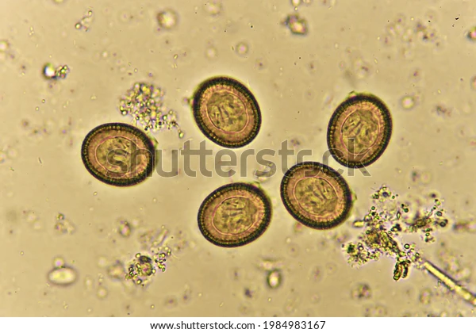

Differences: saginata is cattle, tapeworms longer (up to 10m), unarmed, more uterine branches, intestinal only.

### **Echinococcus granulosus (dog) / multilocularis (fox)**

* **Epidemiology:** Sheep-raising regions (Mediterranean, Middle East, South America, China).
* **Transmission:** Ingestion of eggs from dog faeces.
* **Clinical:** Hydatid cysts (liver, lung); rupture → **anaphylaxis**; *E. multilocularis* → invasive hepatic disease.
* **Diagnostics:** Imaging (US/CT), serology.
* **Treatment:** Albendazole ± PAIR (puncture-aspiration-injection-reaspiration) or surgery.

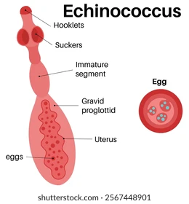

### **Diphyllobothrium latum**

* **Epidemiology:** N. Europe, Japan; **raw freshwater fish.**
* **Clinical:** Intestinal tapeworm; **B12 deficiency → megaloblastic anaemia**.
* **Diagnostics:** Operculated eggs in stool.
* **Treatment:** Praziquantel.
* 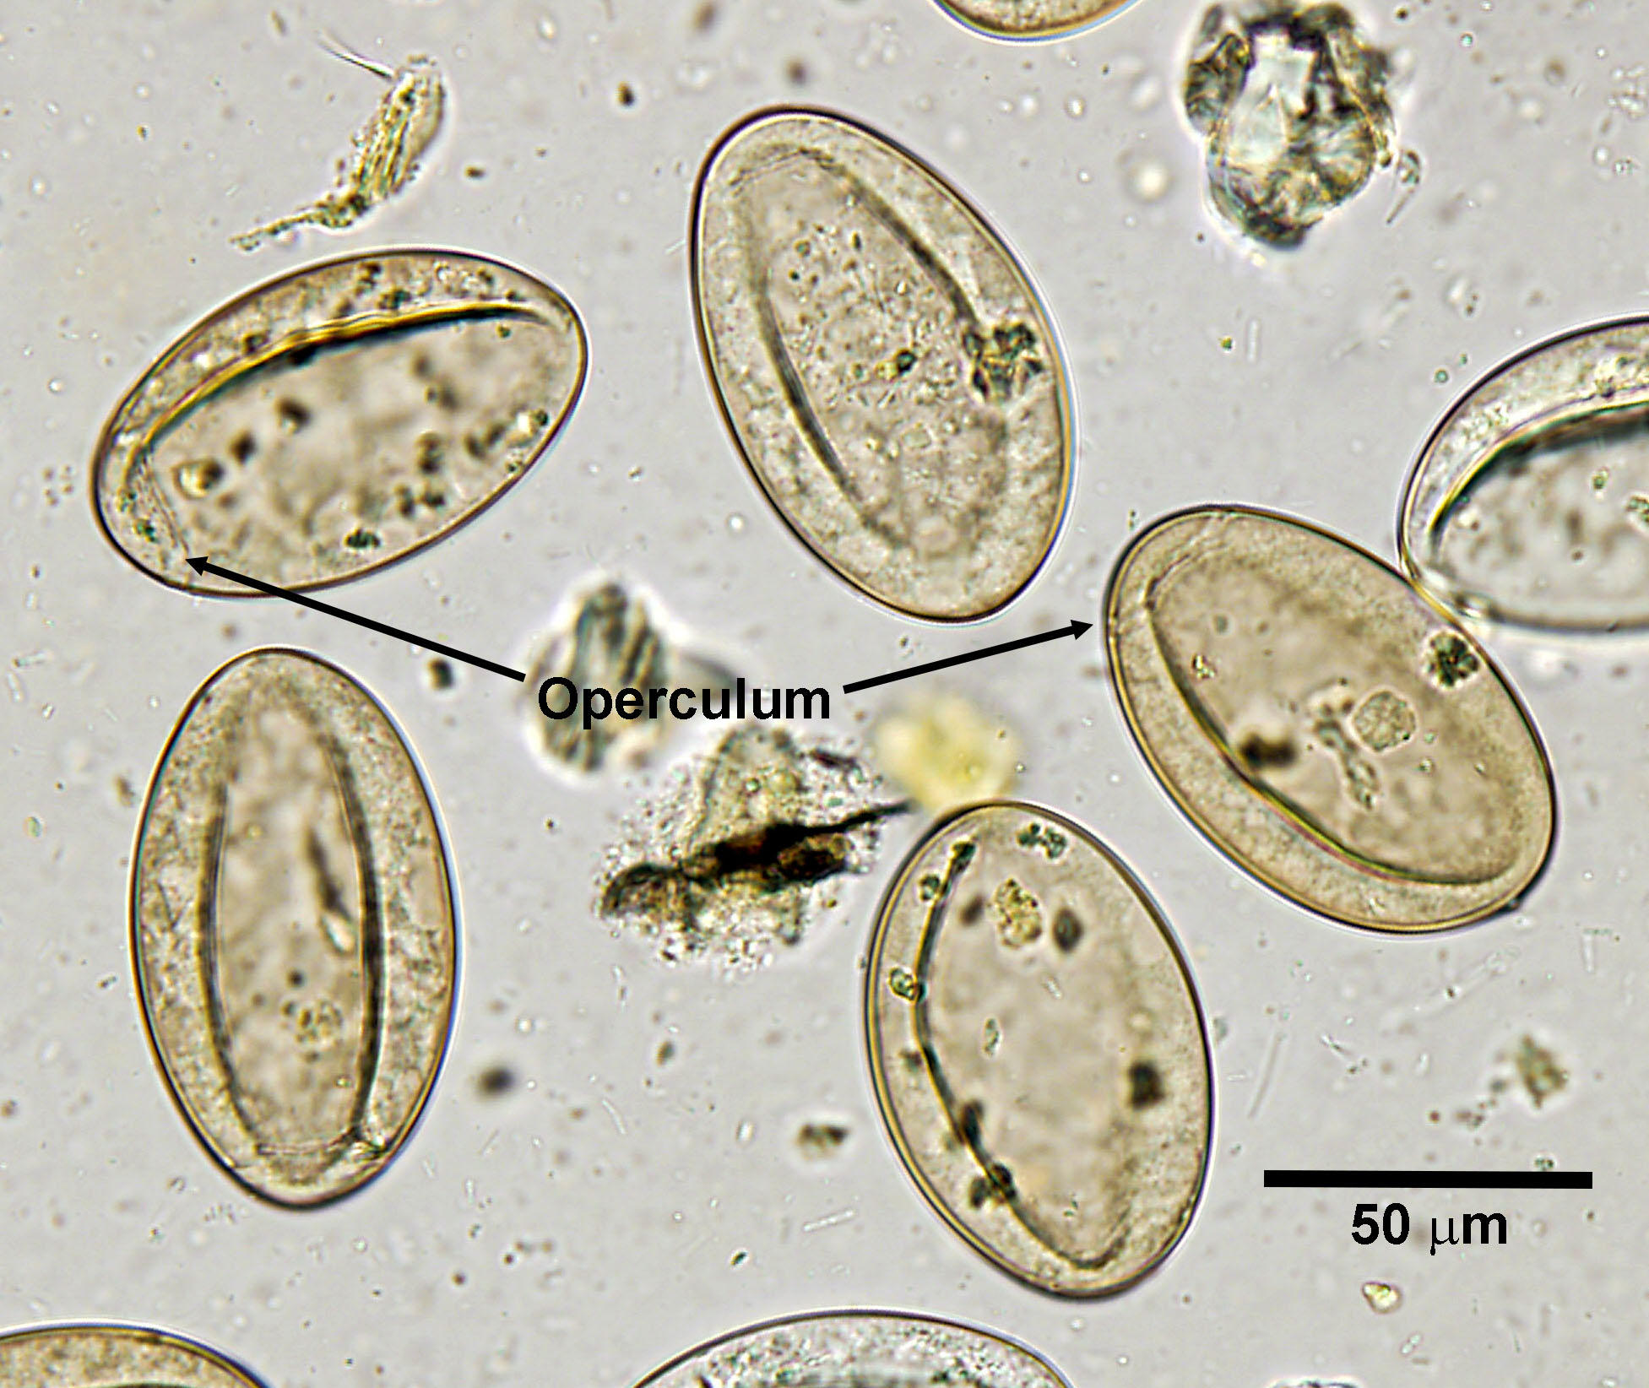

### **Hymenolepis nana**

* **Epidemiology:** Worldwide, esp. children.
* **Transmission:** Ingestion of eggs; autoinfection possible.
* **Clinical:** Diarrhoea, abdominal pain.
* **Diagnostics:** Eggs in stool (polar filaments).
* **Treatment:** Praziquantel.

## **3. Nematodes (Roundworms)**

### **Ascaris lumbricoides**

* **Epidemiology:** Most common helminth worldwide.
* **Transmission:** Ingestion of embryonated eggs in contaminated food/soil.
* **Clinical:** Loeffler’s pneumonitis (larval migration), intestinal obstruction, biliary colic.
* **Diagnostics:** Large mammillated eggs in stool.
* **Treatment:** Albendazole/mebendazole.

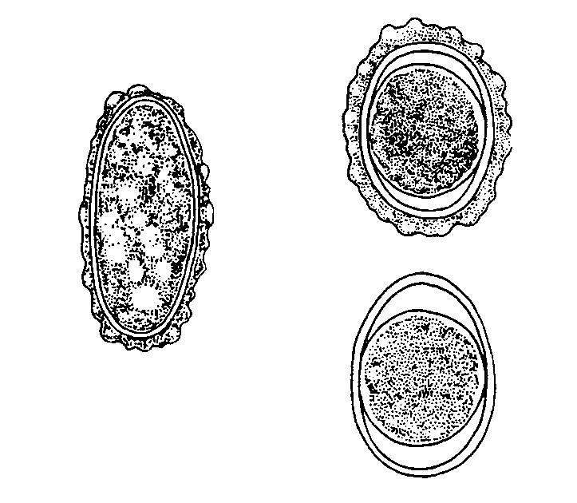

### **Trichuris trichiura (Whipworm)**

* **Transmission:** Ingestion of eggs.
* **Clinical:** Dysentery, rectal prolapse in heavy infections.
* **Diagnostics:** Barrel-shaped eggs with bipolar plugs.
* **Treatment:** Albendazole/mebendazole.

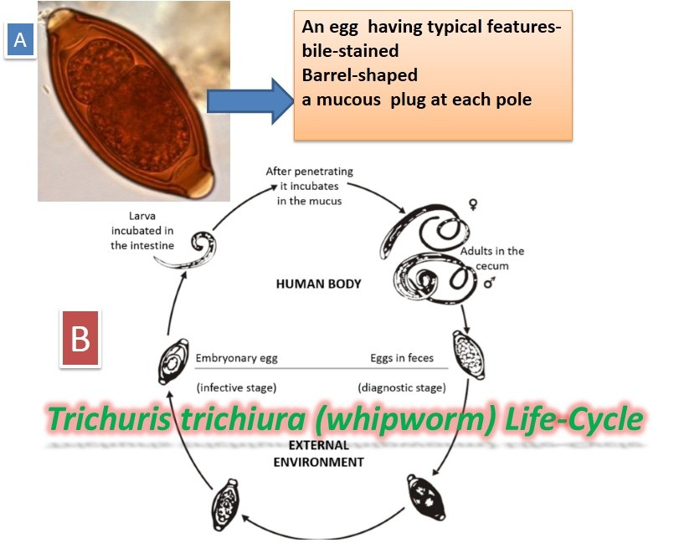 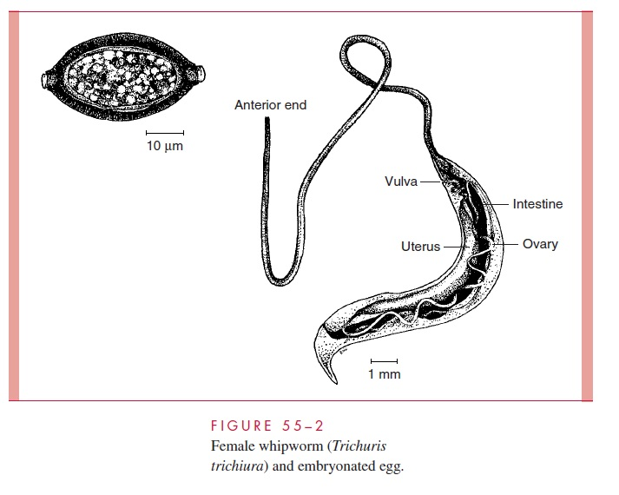

### **Enterobius vermicularis (Pinworm)**

* **Epidemiology:** Common in children.
* **Transmission:** Ingestion of eggs (perianal → hand → mouth) > **autoinfection**
* **Clinical:** Perianal itch (worse at night).
* **Diagnostics:** “Scotch tape test.”
* **Treatment:** Mebendazole; treat household contacts.

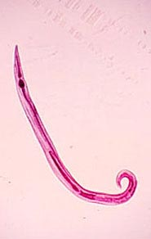 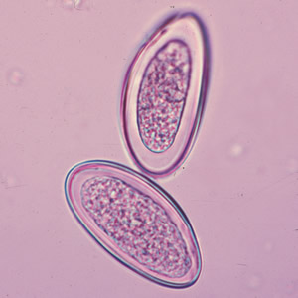

### **Strongyloides stercoralis**

* **Transmission:** **Skin penetration by larvae**.
* **Clinical:** Asymptomatic or mild diarrhoea; **hyperinfection in immunocompromised (esp. steroids, HTLV-1), associated with Gram negative sepsis**
* **Diagnostics:** Rhabditiform larvae in stool, serology, PCR.
* **Treatment:** **Ivermectin** (not albendazole).

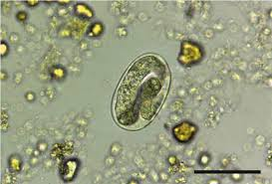 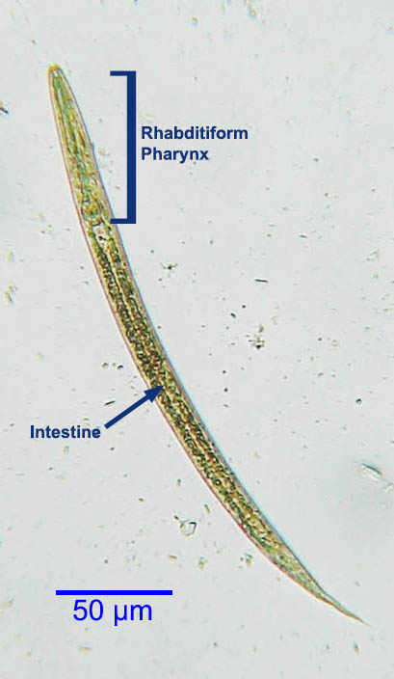 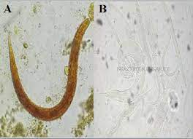

### **Hookworms (Ancylostoma duodenale, Necator americanus)**

* **Transmission:** **Skin penetration by larvae.**
* **Clinical:** Iron deficiency anaemia, malnutrition.
* **Diagnostics:** Thin-shelled eggs in stool.
* **Treatment:** Albendazole/mebendazole.

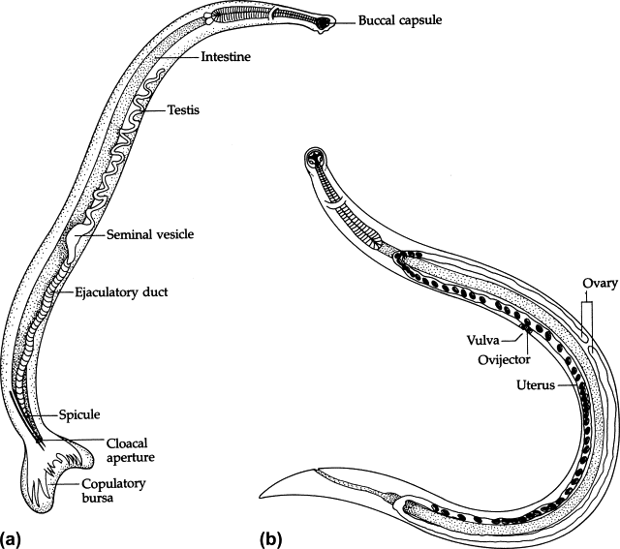 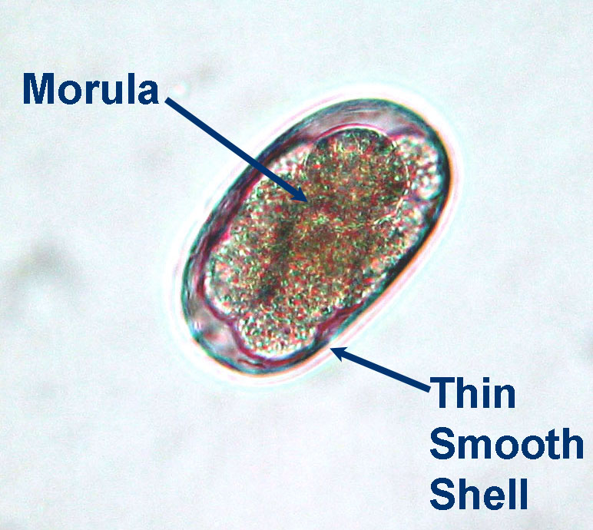

### **Trichinella spiralis**

* **Transmission:** Ingestion of encysted larvae in undercooked pork/wild game.
* **Clinical:** Myositis, fever, eosinophilia, periorbital oedema.
* **Diagnostics:** Muscle biopsy, serology.
* **Treatment:** Albendazole/mebendazole + steroids if severe.

### **Dracunculus medinensis (Guinea Worm)**

* isolated cases in Chad/Ethiopia
* **Transmission:** Drinking **water with copepods** carrying larvae.
* **Clinical:** Painful skin ulcer with emerging worm.
* **Diagnostics:** Clinical.
* **Treatment:** No drug; slow extraction of worm. WHO eradication programme.

### **Toxocara canis/cati**

* **Transmission:** Ingestion of dog/cat roundworm eggs.
* **Clinical:** **Visceral larva migrans, ocular larva migrans.**
* **Diagnostics:** Serology (ELISA), eosinophilia.
* **Treatment:** Albendazole ± steroids.

### **Filarial worms**

* **Wuchereria bancrofti / Brugia malayi**
  + **Geography:** Africa, Asia, Pacific, India.
  + **Transmission:** Mosquito bite.
  + **Clinical:** Lymphatic filariasis → elephantiasis.
  + Diagnosis: Peripheral films
  + **Treatment:** DEC + albendazole.
* **Loa loa**
  + **Geography:** West and Central Africa (rainforest belt).
  + **Transmission:** Chrysops fly (day-biting).
  + **Clinical:** Calabar swellings, migrating eye worm.
  + **Treatment:** DEC (caution with high microfilarial loads).
* **Onchocerca volvulus**
  + **Geography:** Sub-Saharan Africa, Yemen, Central/South America (riverine areas).
  + **Transmission:** Blackfly (fastflowing riverine areas).
  + **Clinical:** River blindness, dermatitis, hanging groin.
  + **Diagnostics:** Skin snip microfilariae.
  + **Treatment:** **Ivermectin** (DEC contraindicated due to Mazzotti reaction).

## **4. Tissue Nematodes (Zoonotic)**

### **Anisakis spp.**

* **Epidemiology:** Japan, raw/undercooked marine fish.
* **Clinical:** Acute abdominal pain (gastric anisakiasis).
* **Diagnostics:** Endoscopy (larva).
* **Treatment:** Endoscopic removal.

### **Capillaria philippinensis**

* **Transmission:** Ingestion of raw freshwater fish.
* Epidmiology: Phillipines, Thailand
* **Clinical:** Malabsorption, chronic diarrhoea, wasting.
* **Treatment:** Albendazole.

## **🔑 Extra Exam Pearls**

* **Eosinophilia** → classic for tissue-migrating helminths (schistosomes, strongyloides, filariae, trichinella, toxocara).
* **Cancer links** → S. haematobium (bladder), Clonorchis/Opisthorchis (cholangiocarcinoma).
* **Treatment pitfalls** →
  + Fasciola → triclabendazole (not praziquantel).
  + Strongyloides → ivermectin (not albendazole).
  + Onchocerca → ivermectin (not DEC).
* **Public health** →
  + Schisto MDA with praziquantel.
  + Filariasis elimination with DEC + albendazole.
  + Guinea worm near-eradication.
* **Diagnostics** → stool/urine microscopy, serology, antigen tests, PCR, imaging (hydatid, neurocysticercosis).
* **Other** → *Echinococcus* cysts (risk of anaphylaxis), *Strongyloides* hyperinfection in immunosuppressed.

